**Monopoly Game**

**Team Name: Double M Triple C**

* Mina Milad Anwar

Sec: 18

ID: 2017170468

* Mariam Boshra Mahrous

Sec: 16

ID: 2017170420

* Catherine Magdy Azar

Sec: 11

ID: 2017170291

* Christina Ibrahim Sadek

Sec: 11

ID: 2017170292

* Christina Magharious Tanious

Sec: 11

ID: 2017170293

**Uml Diagram**

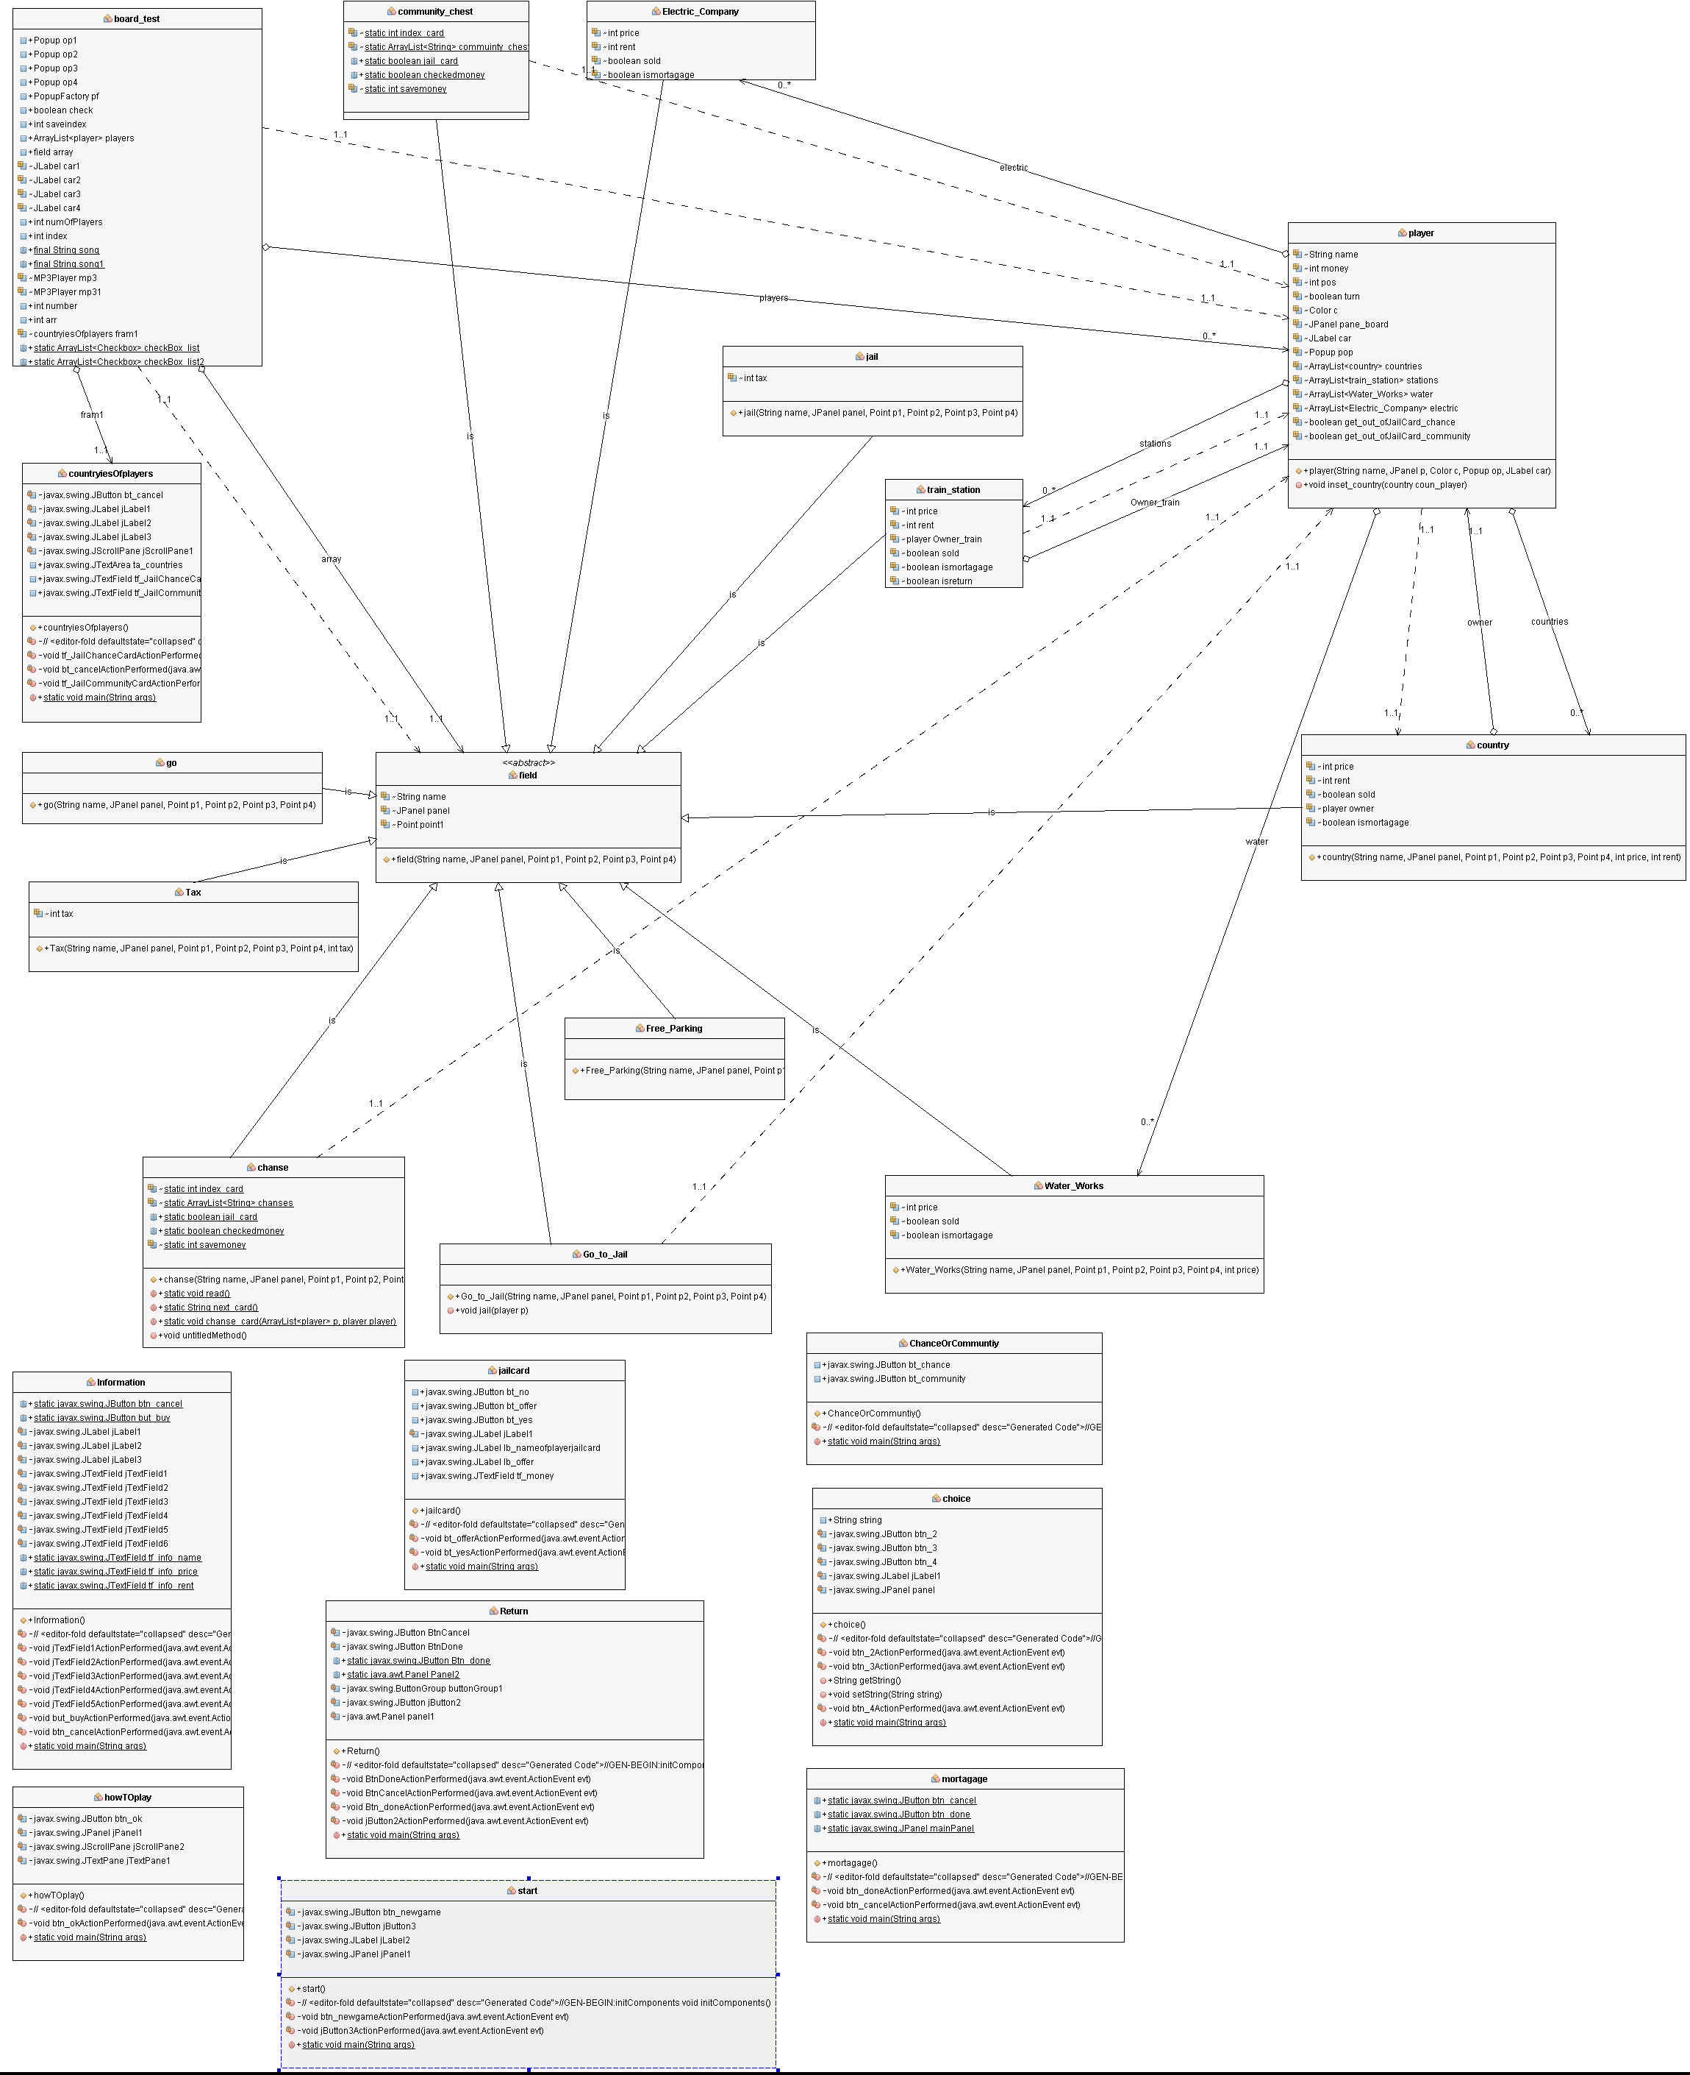

**Flowchart**

